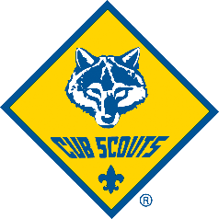
Do you hear that?
Sounds like a…
STAMPEDE!!!

Saturday, October 21st
9:00am – 4:00pm
At
Fire Mountain Scout Camp
26027 Walker Valley Road, Mount Vernon, WA 98274

Come enjoy a day of fun and exciting Scout activities like
Shelter Building,
Orienteering (map and compass),
BB, archery, and sling shot ranges,
Campfire and s’mores,
Fishing,
… and much more!

Come for an hour, or come for the day!
Don’t forget your fishing pole and $2 for the hotdog lunch

