Saturday, September 22, 2018
Fire Mountain Scout Camp
STORM THE FORT!

Check-in: 8:00 a.m.
Games begin: 9:00 a.m.
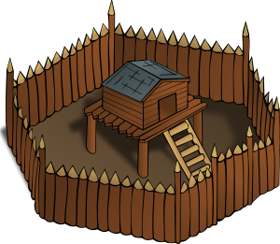
Lunch & Prizes: ~ 1:00 p.m.
What: “Storm the Fort” is a fun-filled Scouting skills competition for adults, featuring archery, canoeing, orienteering, wilderness survival, catapults, and slingshots, plus riding Fire Mountain’s zip line! Participants will compete in teams (patrols) of six individuals working together to win prizes, enjoy the great outdoors, and share their experiences over lunch. We are excited to invite all our Scouting friends and members of the broader community to show off their outdoor skills! All proceeds support local Scouting programs that serve young people and families in Snohomish, Skagit, Whatcom, Island and San Juan Counties.

Location: Fire Mountain Scout Camp
26027 Walker Valley Road
Mount Vernon, WA 98274

Format: Teams (“patrols”) of six will compete in seven different Scouting skills competitions each lasting up to
30 minutes. Each station will be judged separately, with points being awarded to crown an
overall champion. Competition is limited to the first 21 teams to register. Must be 18 to register.

Registration for Participants:

Team Sponsor $300: Entry cost for one patrol (team) of six adults
Individual Participant $50: Will be placed into a patrol (team) of six adults

Sponsorship Opportunities:

Station Sponsor: $500, plus station prizes
Company logo and merchandise at station, provide station prizes to the
top patrol at station, prominent promotion prior to event on website.

Lunch Sponsor: Provide lunch for 120+ adult Scouters and supporters who competed in seven
grueling events over the morning. On-site and on-line recognition.

Refreshment Sponsor: Provide water and power bars at competition stations to support the
competitors. On-site and on-line recognition.

Return Registration to Mount Baker Council, BSA Address: 1715 100th Place SE, Suite B, Everett, WA 98208

Make check payable to ‘Mount Baker Council, BSA’ or call (425)338-0380 to pay with debit/credit card by phone

Patrol/Team Name: ___________________________________________________

Name:_________________________________
(Team lead or individual registrant)

Phone: ________________________________

Email: _________________________________

Team Participants:

_________________________________________________________________________________

_________________________________________________________________________________

